**Saint Brigid Saint John the Baptist**

14th Sunday in

Ordinary Time

July 8, 2018

**Catholic Church Catholic Church**

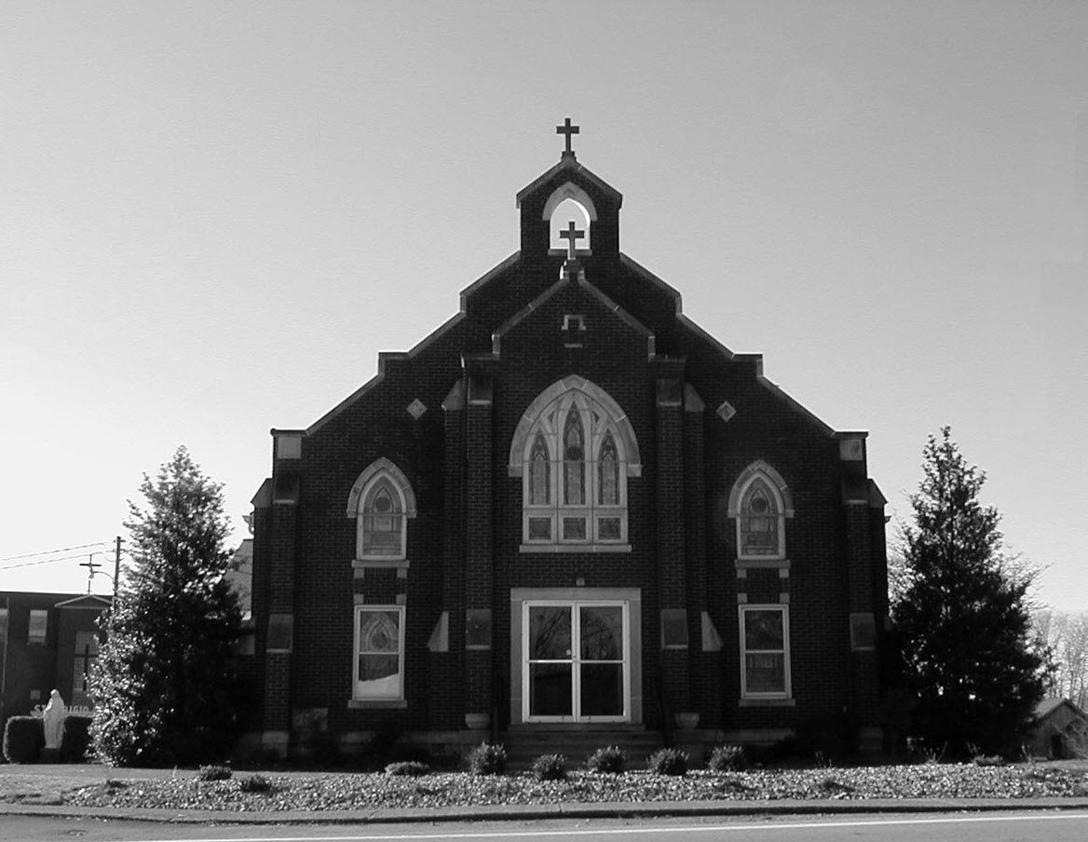

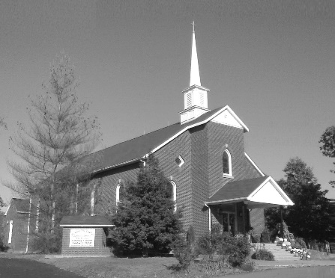

**Pastor:**

***Rev. Daniel L. Lincoln***

Rectory: (270) 877-2546

**Deacon:**

***Michael A. Ryan***

(270) 272-6789

314 E. Main St. 657 St. John Church Rd.

Vine Grove, KY 40175 Elizabethtown, KY 42701

Clustered Parish Office: Clustered Parish Office:

(270) 877-2461 (270) 877-2461

**ANNOINTING OF THE SICK:**

Notify the parish office when a family member is hospitalized.

**BAPTISM:**

Contact the parish office for information about the required preparation class.

**BULLETIN:**

Information must be submitted in writing by note or email to the parish office **no later than 12:00 noon on Wednesdays** for the following weekend. When sending an email, please put “BULLETIN,” and the name of the parish the announcement is for, in the subject line.

**MARRIAGE:**

Contact Father at least 6 months prior to the wedding date to complete required marriage preparations and to schedule the date.

**RCIA (Rite of Christian Initiation of Adults):**

Contact the Worship Chairperson for information.

**DEW MEMORIAL LIBRARY:**

(in St. Brigid Church basement):

Open: Sunday after 9:30 a.m. Mass& 45 minutes before all other Masses.

Email: [brigidvg@bbtel.com](mailto:brigidvg@bbtel.com)

Website: [www.stbrigidvg.org](http://www.stbrigidvg.org)

**Pastoral Associate & Dir. Dir. of Religious Education:**

**of Religious Education:** Lisa Thomas: (270) 735-6930

Deacon Mike Ryan: (270) 877-0546

**Youth Minister: Youth Ministers:**

Lori Law: (270) 723-0157 Angela Churchman:

(270) 268-9963

Ericka Finlay: (502) 612-2644

**MASS SCHEDULE:**

*Sunday:* 9:30 a.m. & 6:30 p.m.

*Monday:* 9:00 a.m.

*Thursday:* 9:00 a.m.

**RECONCILIATION:**

Sunday before Mass

5:30-6:00 p.m. or by appt.

**ROSARY:**

After weekday Masses

**PARISH COUNCIL MEMBERS:**

*President:* Sue Weisshaupt

*Vice-President:* Mike Bramlett

*Secretary:* Judy Cochran

*At-Large Members:* Blake Ryan

& Vincent Thompson

**CHAIRPERSONS:**

*Administration:* Dale Winchester

*Formation:* Tina Yates

*Parish Life:* Tom Billings

*Worship:* Keith Baughman

**MASS SCHEDULE:**

*Saturday (Vigil):*  6:30 p.m.

*Sunday:* 11:30 a.m.

*Wednesday:* 6:30 p.m.

*Friday:* 9:00 a.m.

**RECONCILIATION:**

Saturday before Mass

5:30-6:00p.m. or by appt.

**PARISH COUNCIL MEMBERS:**

*President:* Lauran Thomas

*Secretary:* Theresa Smith

**CHAIRPERSONS:**

*Administration:*  Nick Thomas

*Formation:* Ericka Newton

*Parish Life:* Bradley Wickersham

*Worship:* Greg Thompson



**Mass Schedule**

**Mass Schedule**

|  |  |  |  |  |  |
| --- | --- | --- | --- | --- | --- |
| **Saturday** | **July 7** | **6:30 p.m.** | **St. John** | **Living & Deceased Emil & Anna Brangers Family Members** | **Vigil: 14th Sunday in Ordinary Time** |
| **Sunday** | **July 8** | **9:30 a.m.** | **St. Brigid** | **Our Parish Family**  **Carlos Robbins** | **14th Sunday in Ordinary Time** |
| **“** | **“** | **11:30 a.m.** | **St. John** | **For All Parishioners** | **“** |
| **“** | **“** | **6:30 p.m.** | **St. Brigid** | **Richard Hughes**  **Helen C. “Dinky” Adams** | **“** |
| **Monday** | **July 9** | **9:00 a.m.** | **St. Brigid** | **Dickie Cecil**  **Richard Hughes** | **Weekday** |
| **Wednesday** | **July 11** | **6:30 p.m.** | **St. John** | **Bruce & Margaret Lincoln** | **St. Benedict, Abbot** |
| **Thursday** | **July 12** | **9:00 a.m.** | **St. Brigid** | **Dorothy Hulsman**  **Arthur R. Kieta** | **Weekday** |
| **Friday** | **July 13** | **9:00 a.m.** | **St. John** | **For Those Who Have Cancer** | **Weekday** |
| **Saturday** | **July 14** | **6:30 p.m.** | **St. John** | **For Good Health** | **Vigil: 15th Sunday in Ordinary Time** |
| **Sunday** | **July 15** | **9:30 a.m.** | **St. Brigid** | **Mack, Leanna & Billy Cecil** | **15th Sunday in Ordinary Time** |
| **“** | **“** | **11:30 a.m.** | **St. John** | **For All Parishioners** | **“** |
| **“** | **“** | **6:30 p.m.** | **St. Brigid** | **Our Parish Family**  **Wintermayr - Munz** | **“** |

**INFORMATION FOR BOTH PARISHES**

**GUIDE BOOK & DIRECTORY ADVERTISING OPPORTUNITY** – We are in the process of updating our annual Guide Book & Directory for our churches. This book will contain everything pertinent to our church: the various ministries, organizations, committees, activities, functions and events plus a complete directory of all members. This book is being provided and direct-mailed to each family at no cost to our church, and it is again being subsidized by local businesses that advertise. If you own or manage a business and would like to find out about advertising in our book, please call the Church Office. Recent survey results by Guide Book Publishing show that 92.1% of families would rather patronize a Guide Book & Directory advertiser over a non-advertiser. It “will pay” to advertise in our new Guide Book & Directory.

**ABORTION AND ADOPTION –** The number of would-be adoptive parents (of newborn babies) far outstrips the supply in America. Each year in the United States, about 135,000 American children are placed for adoption. Experts estimate somewhere between one and two million couples seek to adopt yearly. Every year, there are about 1.3 million abortions. Sadly, only 4% of women with unwanted pregnancies give their children up for adoption. Every child is wanted and wanted desperately! By Pro-Life Articles Author [www.pro-lifearticles.org](http://www.pro-lifearticles.org)

**PROJECT RACHEL** **–** Healing…Forgiveness…Hope…After the experience of an abortion. If you or someone you know is struggling with the pain from an abortion, please consider Project Rachel – a post abortion ministry. To speak to someone confidentially, call (502) 471-2155 or email [ProjectRachel@archlou.org](mailto:ProjectRachel@archlou.org).

**CONFIDENTIAL PREGNANCY AND ADOPTION COUNSELING** – is available at Catholic Charities for women of all ages experiencing untimely pregnancies. A full range of services are provided, including adoptive placement, legal assistance and counseling for individuals, groups and families. Post-abortion counseling is also available. Services are provided regardless of income or marital status. For more information, call Catholic Charities at (502) 637-9786.

**SAVE THE DATE** – Fr. John Judie will have a celebration of his retirement, 70th birthday and 31 years of priestly ministry on **Saturday, August 11, 2018**. More details will follow later. He may be reached at (502) 774-5772.

**St. John and St. Brigid Prayer List**

To add someone to the prayer list, please call the parish office at (270) 877-2461. **Remember to call to remove someone from the list if they are no longer sick, etc.** *Please note that the prayer list has been revised. It is primarily for parishioners and their immediate family members*.

Leslie **Adams-Cerniglia**, Sam **Adams**, April **Allen**, Dennis **Arnold**, Barbara **Ashley**, Donnie Alan **Atcher**, Sue **Banks**, Shannon **Barnes,** Denise **Barnett**, Timothy **Birch**, Teresa **Blaycock**, Charlie **Bowers**, Pauline **Brangers**, Ellen **Bryan**, Richard **Bryson**, Carol **Buchanan**, Jeremy & Margie **Buyer**, Deacon Bob **Caspar**, Sue **Caswell**, Ed **Cecil**, J. Mack **Cecil**, Harlan Ford **Clark**, Judy **Cleaver**, John **Connor**, Betty Jo **Cooper**, Heidi **Correa**, Jeff **Craig**, Glynn **Clutches**, Roan **Dowell**, Karen **Dworshak**, Leroy **Embry**, Marion **French**, Martha **Ford**, Dwayne **Garcia**, Carrie **Gribben**, Mary **Hager**, Mrs. Charles **Hair**, Stephanie **Hall**, Donnie **Hart**, Jimmy **Harper**, Bobby **Harris**, Eileen **Heinen**, Debbie **Hodge**, Betty Lou **Jones**, Andrew **Kieta**, Charlene **Langley**, Olivia **Leasor**, Jenny **Leonhardt**, Jackie **Long**, Louise **Lucous**, Alma **Mahanna**, Shelly **Martin**, Shirley **Martin**, Martina **Masoni**, Don **Mattingly**, Gerard **Mattingly**, Paul Michael **Mattingly**, Mary **Medley,** Cindy **Miller**, Starla **Miller**, Doug **Osborne**, Duane **Osborne**, Fr. Stan **Osborne**, Mickey **Padgett**, Frank **Inanely**, Jerry **Phillips**, Annie **Pierce**, Adrianna **Porter**, Jeremy **Porter**, Adrian **Ray**, Allie **Ray**, Mary Agnes **Ray**, Mary Ellen **Ray**, Tonya **Reisinger**, Joel **Rivera**, Pat **Ryan**, Caroline **Seabee**, Ralph **Staples**, Keith **Tassin**, Kenny **Thompson**, Raffaella **Tucker**, Debi **Turner**, Stacey **Vance**, Charlotte **Vowels**, Bill **Waldrop**, Lois **Weaver**, De Neil **Whelan**, Paul A. **Whelan**, Jennifer **Williams**, Sandy **Wiseman**, Zach **Wiseman**, Gail **Wilson**, Don **Wooldridge**, Connor **Wright** and all the sick.

* * * * * * * * * * * * * * * * * * *

**Our Military List**

To add someone to the military list, please call the parish office at (270) 877-2461. **Remember to call to remove someone from the list if they are no longer in the service**.

Lt. Matt **Bednar**, PFC Richard H. **Chapman**, A1C Aaron **Chandler**, A1C Brandon **Davila**, SrA Felicia **Esquivel**, PFC Tyler **Hall**, A1C Ryan **Henley**, A1C Joseph **Manco**, SPC Jacob L. **Nall**, SFC Peter **Novak**, Tony **Rickerl**, Lt. Col. Paul **Rigby**, 0James **Rogers**, Tony **Rogers**, Jonathon **Sifford**, Jeffrey **Slade**, Derek **Smith**, CSM Vance **Snider**, Brian **Tomassi**, A1C Daniel **Trombone**, SGT Evan **Vaughan**, PV2 William **Vaughan**, Lisa **Flynn-Veri**, LT Michael **Veri**, LTC Steve **Wickersham**, SGT Clay **Wilson**, TSGT Jeremy **Yates**, Austin **Zulka** and for all who serve and have served our country.

* * * * * * * * * * * * * * * * * * *

**ST. JOHN THE BAPTIST CATHOLIC CHURCH INFORMATION**

**Monthly Budget Amount Needed:** $ 12,500.00

**Monthly Collection for June:**  $ 9,153.00

**Monthly Collection for July:** $ 3,190.00

**WELCOME PACKETS** – If you would like to become a member, or learn more about St. John Parish, please take a *Welcome Packet* in the church lobby. You may return the census card and the stewardship form to Father Dan or place in the collection basket.

**UPDATE MEMBERSHIP INFORMATION** – Does our church database have YOUR family membership record correct? Here is your chance to update YOUR record for our annual Guide Book & Directory (if you haven’t already done so). It is time for us to update our database with any changes, additions, or deletions that may have occurred in YOUR family over the past year. Have you changed your phone number? Have you moved? Are you preparing to move soon? Are all of your children still at home and are they all included in your membership record? Do you want your record published? If you have not already informed the Church Office about changes to your record, please let us know now so that the information in the Guide Book & Directory is correct. The Church Office number is (270) 877-2461. *Thank you for your help!*

**DISCRENMENT COMMITTEE UPDATE –** You spoke and we listened!!  One of our first initiatives is for better communication.  Thanks to Dana Ingram and Kolbe Disselkamp we now have a St. John the Baptist Catholic Church Facebook page.  Be sure to like and share this page with all your friends.  We will be posting the weekly bulletin, the list of Mass roles, as well as updates and links to our Vacation Bible School program and our St. John Youth Group. We hope to grow this page with information on all the happenings at St. John so stay connected.  We are also continuing to pursue developing a Web page for the Church.  Anyone with any insight on this please don't hesitate to contact one of us on the committee or let Father know and we will contact you.  We are also continuing to finalize our Stewardship committees.  If you haven't completed your Stewardship Form, it's not too late.  Forms are in the back of Church.  We will also be emailing and mailing out reminders to people that we think might have been missed so get those forms turned in.  Also, watch in August as we will start having organizational meetings for each newly formed committee to review duties and to kick off some of our new ministries.  You can still join or participate in any on these events as they are scheduled.  Don't think just because you didn't sign-up that you can't change your mind and join in.  If something looks interesting to you just show up and join in.   Committee members are:  Clarissa Yates, Erick Finlay, Rick Newton, Karen Ray, Rhonda Newton and Lisa Thomas.

**PARISH COUNCIL MEMBERS** – President – Lauran Thomas; Secretary – Theresa Smith; Administration – Nick Thomas; Formation – Ericka newton; Worship – Greg Thompson and Parish Life – Bradley Wickersham.

**HABITAT** – Thanks again to the St. John Friends of Habitat for providing kitchen items for the Churchill Home that was dedicated on Saturday, June 16. With your donations, some of the items purchased were: 8 place setting of stoneware, 8 place setting of silverware, 9 pc. cookware, baking pans and dishes, dishtowels/cloths, bath towels/cloths, crockpot, pitcher/glasses, mixing bowls, cutting board, kitchen utensils, etc. This is House #18 for which you have provided items. Your continued generosity to Habitat is a blessing.. THANK YOU!

**DATE CHANGE FOR VACATION BIBLE SCHOOL** – We are changing VBS to a three-day program, starting **Monday, July 16 and ending Wednesday, July 18. 6:00 p.m. to 8:30 p.m.** Our theme is *Shipwrecked-Rescued by Jesus*.  If you have any lanterns, oars, etc. that we can use for decorations, please let me know.  If you have any questions, please contact Clarissa Yates, [cpyates@comcast.net](mailto:cpyates@comcast.net) or (270) 862-3792. There will be a brief meeting for Vacation Bible School after the 11:30 mass on Sunday, July 8.  I urge all volunteers to come as this will be our last meeting before Bible School begins.

**VACATION BIBLE SCHOOL** – Pre-register for VBS by going to **vbspro.events/p/fbefde** and choose participant registration. St. John will be at the top. You can also sign-up to volunteer too. If n you have any questions, please contact Clarissa Yates at (270) 862-3792 or [cpyates@comcast.net](mailto:cpyates@comcast.net).

**NEW YEAR KICK OFF!** Join us for a pool party/cook out to kick off the beginning of the 2018-2019 Youth Group year! We are extending this invitation to any youth entering 6th-12th grade. We are encouraging those who have never attended youth group to join us as well to see what we're all about! **The pool party will be at Rick and Rhonda Newton's house from 6:00-8:00 p.m. on Thursday, July 26.** Food will be provided - just bring your own towel. Please RSVP to Ericka or Angela by **Tuesday, July 24,** so we have enough food. You can also text/call one of us for the address.

**SAFE ENVIRONMENT TRAINING –** Anyone 18 and older, volunteering in our parish with the RE program, Youth Group, VBS, etc. must attend a Safe Environment Training Seminar sponsored by the Archdiocese.  These are scheduled at various times throughout the Archdiocese. The complete list of available dates can be accessed on the Archdiocese website.  The next scheduled training in our area will be **Thursday,** **August 23, at 6:30 p.m. at St. James Church, Batcheldor Hall in Elizabethtown.** Any questions regarding this training please contact Lisa Thomas  (270) 735-6930 or [glalt@comcast.net](mailto:glalt@comcast.net).  If you attend this training, please be sure to return your completed form to Lisa Thomas.

**FR. STAN OSBORNE** – can be reached at Nazareth Home, Room 112, 2000 Newburg Rd., Louisville, KY 40205.

* * * * * * * * * * * * * * * * * * *

**St. John Liturgical Ministers**

|  |  |
| --- | --- |
| **Vigil: 15th Sunday in Ordinary Time, July 15, 2018, 6:30 p.m.** |  |
| Extraordinary Ministers of the Eucharist | Joanna Sherrard Abby Newton Rhonda Newton |
| Lector | Dennis Thomas |
| Servers | Volunteers |
| Greeter(s) | Ericka Newton |
| Gift Bearers | Newton Family |
| - Ushers | John Thomas Kenny Heibert |
| **15th Sunday in Ordinary Time, July 15, 2018, 11:30 a.m.** |  |
| Extraordinary Ministers of the Eucharist | Lucy Ramos Martha Thomas Scott Mattingly |
| Lector | Martha Thomas |
| Servers | Catherine Updegraff Claire Thomas |
| Greeter(s) | Lisa Thomas |
| Gift Bearers | Updegraff Family |
| Ushers | Kevin Thomas David Pike |
| **Hospital Ministry – Sunday, June 25, 2018** | Marcella Brangers |

**ST. BRIGID CATHOLIC CHURCH NFORMATION**

**Monthly Budget Amount Needed:** $ 25,280.00

**Monthly Collection for June:** $ 21,488.83

**Monthly Collection for July:** $ 10,778.00

**WELCOME VISITORS** – If you are interested in joining our parish, please pick up a Welcome Packet at the church doors. Complete the registration form and either drop it in the collection basket or mail it to the office. If you just need to update your registration, there are also forms available.

**UPDATE MEMBERSHIP INFORMATION** – Does our church database have YOUR family membership record correct? Here is your chance to update YOUR record for our annual Guide Book & Directory (if you haven’t already done so). It is time for us to update our database with any changes, additions, or deletions that may have occurred in YOUR family over the past year. Have you changed your phone number? Have you moved? Are you preparing to move soon? Are all of your children still at home and are they all included in your membership record? Do you want your record published? If you have not already informed the Church Office about changes to your record, please let us know now so that the information in the Guide Book & Directory is correct. The Church Office number is (270) 877-2461. *Thank you for your help!*

**PARISH COUNCIL** – 2018-19 members are President - Sue Weisshaupt, Vice-President – Mike Bramlett, Secretary – Judy Cochran, At-Large Members – Blake Ryan & Vince Thompson.

**EXTRAORDINARY MINISTERS OF THE EUCHARIST** – July through September 2018 EM schedules may be picked up at the back of the church. Thank you for your continued service.

**POT LUCK CELEBRATION** – Join us on **Sunday, August 5, at 4:00 p.m.** as we dedicate our newly renovated school cafeteria. Everyone, who wants one, receives a free copy of the newly published *St. Brigid School Memories* book!

**COMMUNION MINISTER UPDATE SESSIONS** – are for those ministers needing a mandate renewal, who have already completed the archdiocesan two-session Communion Minister Formation Program. This session will fulfill the requirements for continuing formation for Extraordinary Ministers of Holy Communion. I have scheduled the mandatory update session for **September 27, 2018 from 7:00- 9:00 p.m.** Please add to your calendar. I will put the form applications out three weeks before and make sure a new announcement gets into the bulletin. Should you have questions please contact Deacon Mike.

**SUMMER EVENT TICKETS** – are on sale at the back of church on Sundays and at the office.



**QUILT RAFFLE** –This year’s quilt is a blue flower pattern. You will see me in the future outside of church selling the quilt tickets. Don’t pass me by! The quilt will be on display soon near the main doors of the church. Thanks, Janice Jenkins.

**BLOOD DRIVE** – The next drive will be held on **Friday, August 10,** from 10:00 a.m. to 2:00 p.m. in the CCC building. Give the gift of life!! This is more rewarding than what else you have to do today!!

**SUMMER EVENT** – The Summer Event will be **Sunday, September 16**. That way we are not competing with St. Martin’s picnic or the Vine Grove Autumn festival. The lunch is from 1:00-3:00 p.m. The silent auction ends at 3:45 p.m. The main drawing will be at 4:00 p.m. Diane Taylor will cater the meal.  She can do a BBQ pork sandwich, baked beans, either claw slaw or potato salad, sweet and unsweet tea and, water.  She will also do a hot dog for children (or adults that don't want BBQ). We will have the food served in the new cafeteria.  We would still need teens to help serve drinks and bus tables and clean up like we do at the KC Hall now. The Summer Event Ticket Order Forms are at the side doors of the church and the table in the back of church. Should anyone need additional information please contact Teresa Morgan (270) 862-2909; Gina Ryan (270) 735-6355 or Deacon Mike Ryan (270) 877-0546 or (270) 272-6789.

**St. Brigid Youth Ministry**

**Christian Leadership Retreat** – will run from **July 9-13** and is for anyone who has completed their sophomore or junior year of high school. Please contact Lori for more details and permission forms if you are interested. The sooner you apply the better chance of getting a spot and the cheaper it is.

If you have any questions, please contact Lori at (270) 723-0157 or email at [stbrigidyouth@hotmail.com](mailto:stbrigidyouth@hotmail.com).

**St. Brigid Monthly Meet and Greet**

St. Brigid Parish hosts a “Meet and Greet” downstairs the 2nd Sunday of each month immediately following the 9:30 a.m. Mass with coffee and donuts. This is a great opportunity for existing parishioners to extend a warm welcome to visitors and anyone interested in joining St. Brigid Parish. Be sure to also visit the Dew Memorial Library. **The next Meet and Greet will be Sunday, July 8, 2018.**



**Formation News**

Please pick up a "Little Burgundy Book" at the church doors. This booklet follows the same format as the Advent and Lent season booklets, but it is themed for stewardship. It is 4 weeks long and undated so this booklet can be used at any time of the year for personal reflection.

**St. Brigid Liturgical Ministers**

|  |  |
| --- | --- |
| **15th Sunday in Ordinary Time, July 15, 2018, 9:30 a.m.** |  |
| Extraordinary Ministers of the Eucharist P. | Angie Bragg Sherleen Barren |
| C. | Janey Jenkins Denise Hester Rose Cooper |
| Lector | Jim Klimesh |
| Servers | Gabe Russell Maggie Board |
| Greeters | Charles & Pam DeRoche Volunteers |
| **15th Sunday in Ordinary Time, July 15, 2018, 6:30 p.m.** |  |
| Extraordinary Ministers of the Eucharist P. | Richard Osterhage |
| C. | Donna Osterhage |
| Lector | Jackie Veri |
| Servers | Volunteers |
| Greeters | Volunteers |
| **Hospital Ministry – Sunday, August 12, 2018** | Ralph & Sherleen Barren |

***Marriage Moments –***

In a healthy marriage both spouses strive to be good and strong. But, sometimes it is through recognizing our weakness that we can grow stronger. What a mystery! *“…for when I am weak, then I am strong.”* 2 Corinthians 12:10 Can you identify a weakness in yourself that has punctured your pride and made you a better spouse?

***Parenting Pointers –***

July 13 is Friday the 13th which means bad luck to some people. Why not turn the tables and make it a lucky day for someone today. Can you think of a way to make someone feel lucky today?